**LAB EXAMINATION – 2 (COMPUTER NETWORKS)**

**(RA2211003050144)**

Objective:

Set up and configure a network topology using RIP and OSPF routing protocols in Cisco Packet Tracer. Customize the network by assigning each computer a name and an IP address using the last three digits of the roll number. Procedure:

1.NetworkTopologyDesign:

oCreateatopologythatincludes:

▪ 10-12 computers distributed across two LANs.

▪ Use two switches, each connecting a group of computers in a separate

▪ LAN.

Two routers connected via a WAN link. o Device Distribution:

▪ LAN 1: 5-6 computers connected to Switch 1.

▪ LAN 2: 5-6 computers connected to Switch 2.

o Device Naming Convention:

▪ Each computer was assigned a name in the format: PC_RollNumber (e.g., PC_123).

1. IP Address Configuration:

oAssignIPaddressestothecomputersineachLAN.

▪ LAN 1: IP addresses configured with the subnet 192.168.1.0/24, where each PC's IP address ends with the last three digits of the roll number (e.g., 192.168.1.123 for PC_123).

▪ LAN 2: IP addresses configured with the subnet 192.168.2.0/24, similarly using the roll number for the last octet (e.g., 192.168.2.123 for PC_123).o Router Interface Configuration:

▪ Router 1 interfaces were set up with the IP address 192.168.1.1/24 for

▪ LAN 1.

▪ Router 2 interfaces were configured with 192.168.2.1/24 for LAN 2. The WAN link between routers used a point-to-point subnet (e.g., 10.0.0.1/30 for Router 1 and 10.0.0.2/30 for Router 2).

1. Routing Protocols Configuration:

oConfigureRIPv1onRouter1:

▪ Added the network commands for 192.168.1.0 and 10.0.0.0 to enable

RIP routing. o Configure OSPF on Router 2:

▪ OSPF was set up using the area 0 configuration.

▪ Added network commands for 192.168.2.0 and 10.0.0.0.

o Ensuring Communication:

▪ Verified that the routes were properly advertised and shared between the two routing protocols using route redistribution.

1. Packet Tracer Configuration Steps:
   * Add Devices and Create Connections:

▪ Placed all computers, switches, and routers in the workspace.

▪ Connected devices with appropriate cabling (copper straight-through for computers to switches and serial connections for routers).

* + Configure IP Addresses:

▪ Manually set IP addresses for all computers and configured default

gateways. o Set Up Routing:

▪ Enabled RIP on Router 1 and OSPF on Router 2.

▪ Configured route redistribution on both routers for seamless communication. o Verification:

▪ Used the ping command to test connectivity between LAN 1 and

▪ LAN 2.

Verifiedadvertisement. route tables on both routers to ensure correct route

1. Simulation:

oCiscoPacketTracerSimulationMode:

▪ Switchedtosimulationmodetoobservepackettransmission.

▪ InitiatedmessagesendingfromacomputerinLAN1toacomputerin LAN 2.

▪ Verifiedthesuccessfultransmissionofthemessageandinspected routing paths.

1. Documentation and Submission:

oProcedureDocumentation: Step-by-step process of network configuration was documented as described above. oScreenshots: Added all relevant screenshots, covering network design, IP configurations, and successful message transmission. oPacketTracerFile: Saved the .pkt file with the completed configuration.

oGitHubSubmission: Uploaded all documents, screenshots, and the .pkt file

to a GitHub repository named "Lab 2 Exam".oRepositorySubmission: Submitted the GitHub repository link to the instructor.

Output Screenshots:

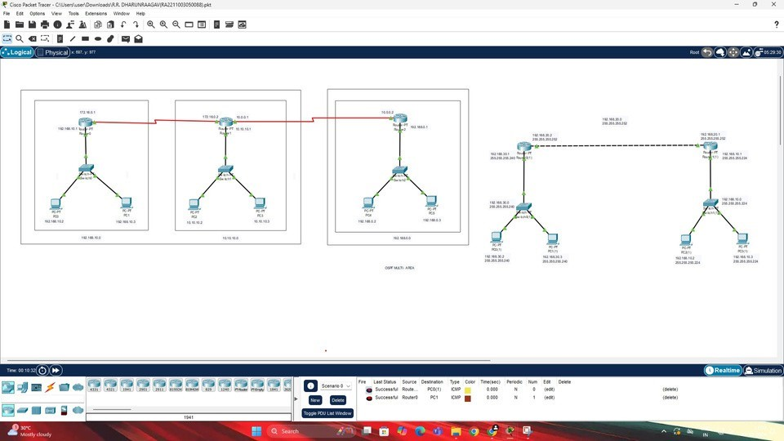

Results:

* Successfully configured a network topology with two LANs using RIP and OSPF routing protocols.
* All devices were assigned IP addresses based on the last three digits of the roll number, maintaining the required subnet structure.
* Routing protocols were configured on the routers, allowing seamless communication between LAN 1 and LAN 2.
* The simulation mode in Cisco Packet Tracer demonstrated successful packet transmission across the network.
* Documentation and files were submitted as per the requirements.

Name: Naveenkannan.D

Class: CSE-C Reg.No: RA2211003050144